- Physical Perspective
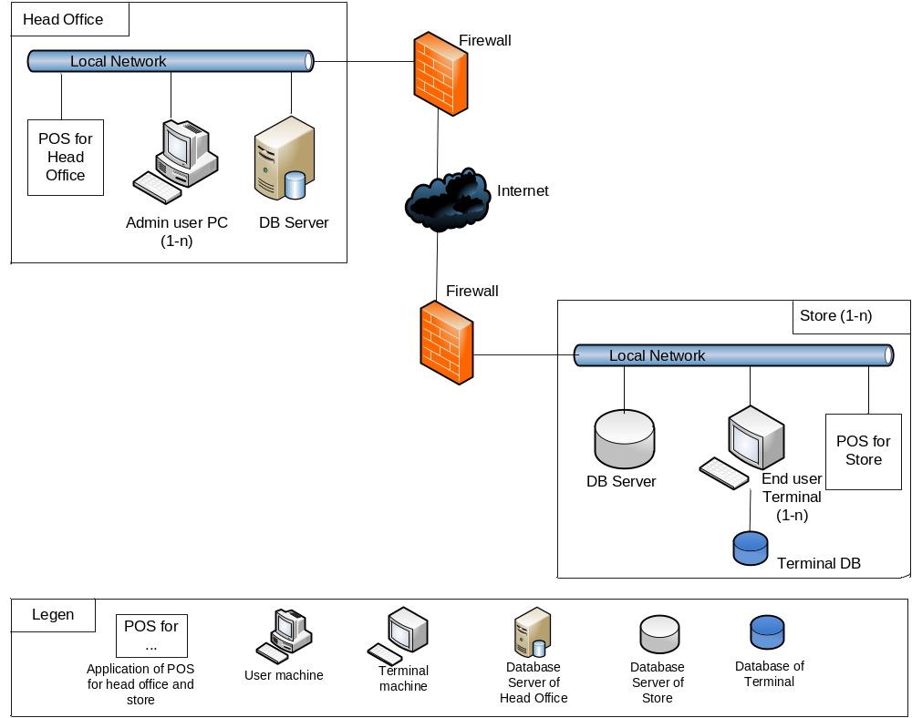
- Static Perspective
  - Level 1
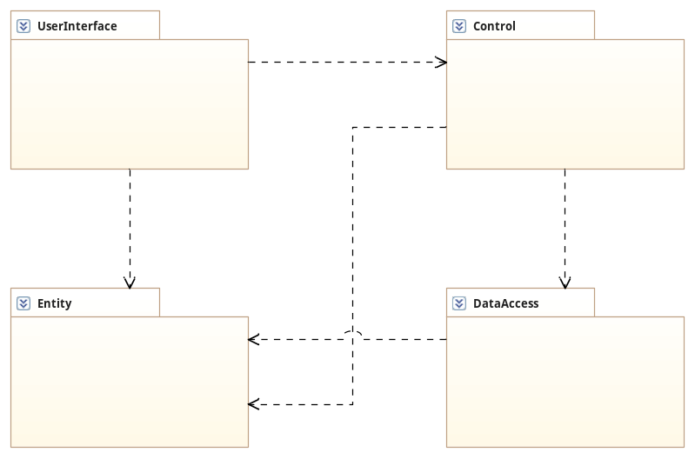
Package | Description
UserInterface | The user interface corresponding to each form of features
Control | The class receive the request from user to handle the business rules
DataAccess | The class receive the request to Data Base from the Control Layer to handle data base
Entity | The class create data object contains data rotation between layers

  - Level 2
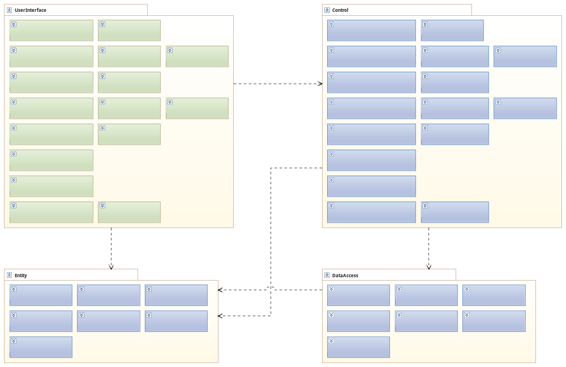
  - Level 3

- Dynamic Perspective

